SIMULTANEOUS EQUATIONS
Pearson Edexcel - Tuesday 11 June 2019 - Paper 3 (Calculator) Foundation Tier

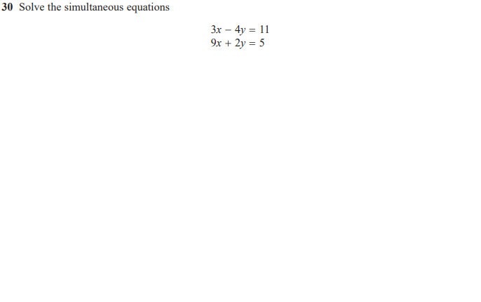

Pearson Edexcel - Tuesday 6 November 2018 - Paper 1 (Non-Calculator) Foundation Tier

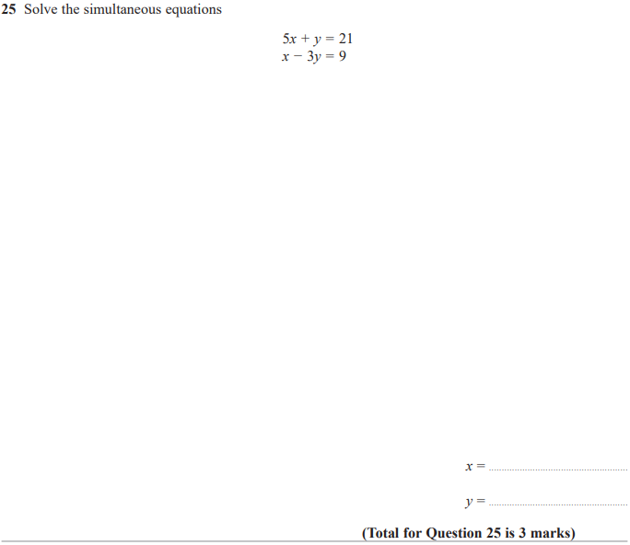

Pearson Edexcel - Wednesday 8 November 2017 - Paper 3 (Calculator) Foundation Tier

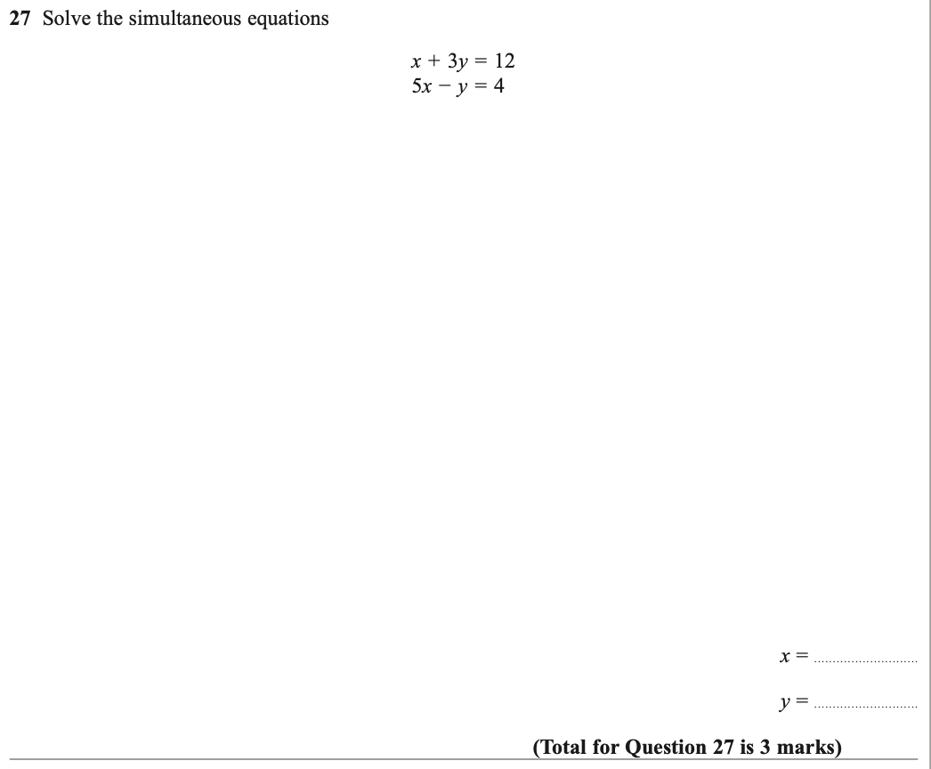

Pearson Edexcel – Specimen 1 - Paper 1 (Non-Calculator) Foundation Tier

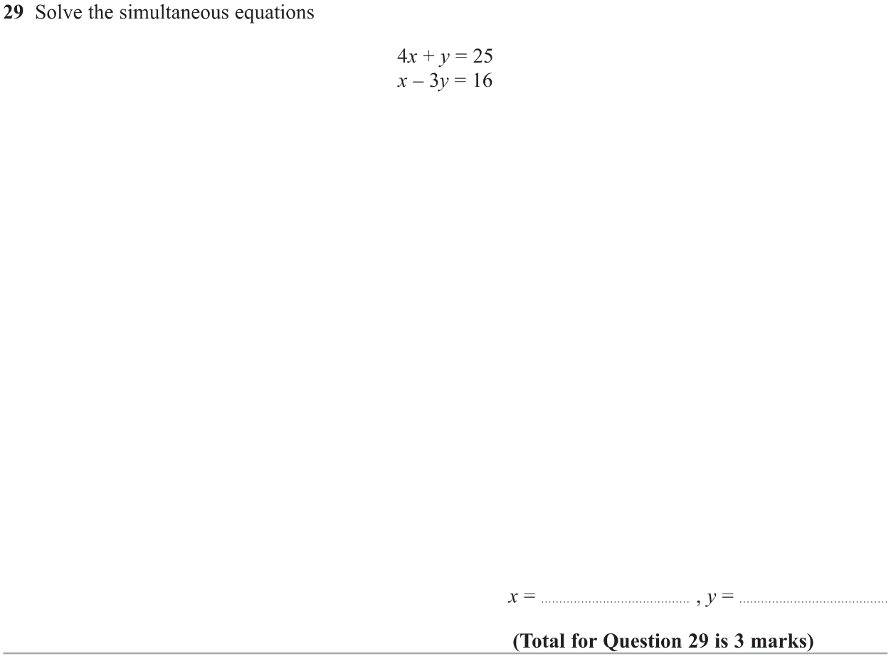

OCR Monday 11 November 2019 – Afternoon (Calculator) Foundation Tier
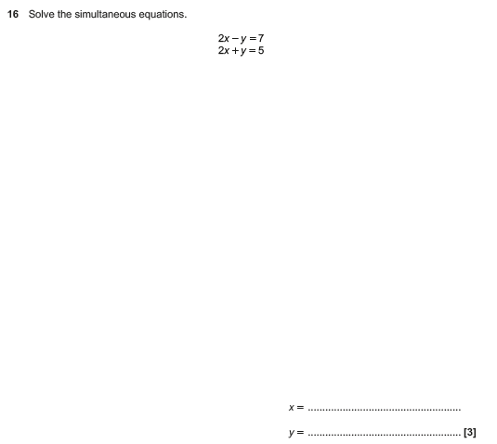

OCR Wednesday 8 November 2017– Morning (Calculator) Foundation Tier

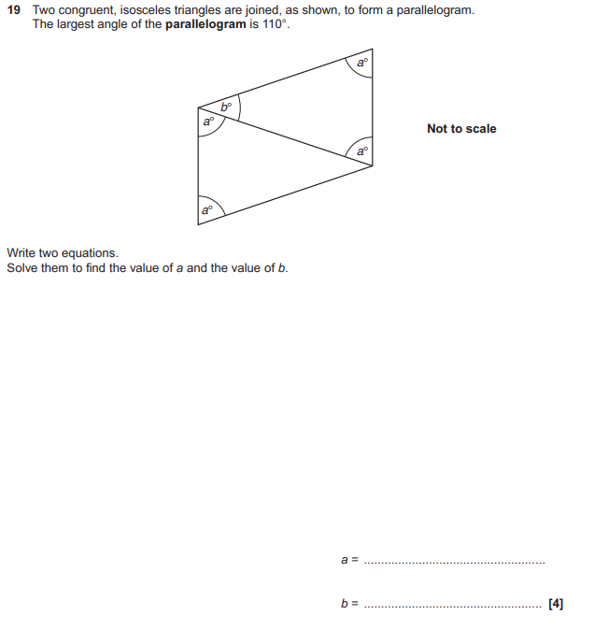

AQA Tuesday 21 May 2019 – Morning (Non-Calculator) Foundation Tier

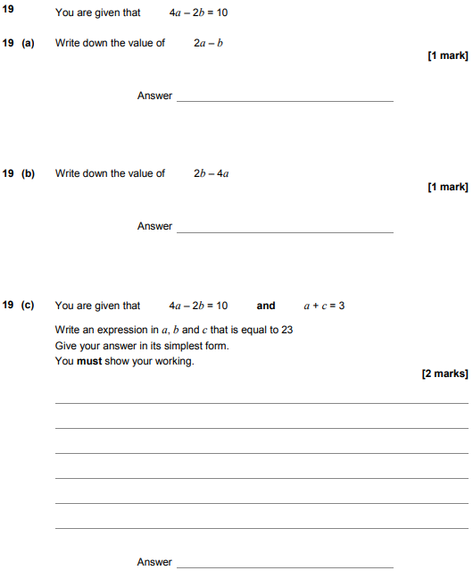

AQA Monday 12 November 2018 – Morning (Calculator) Foundation Tier

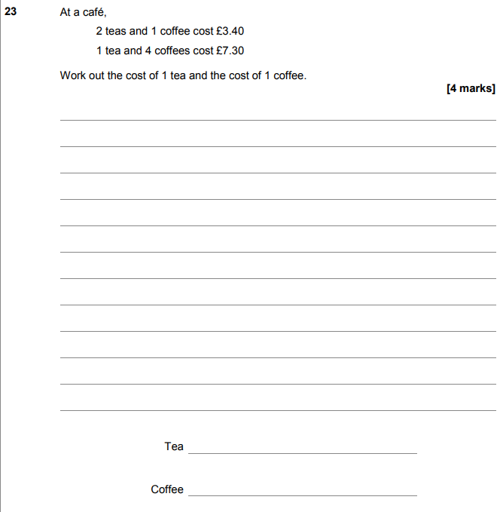

AQA Thursday 24 May 2018 – Morning (Non-Calculator) Foundation Tier

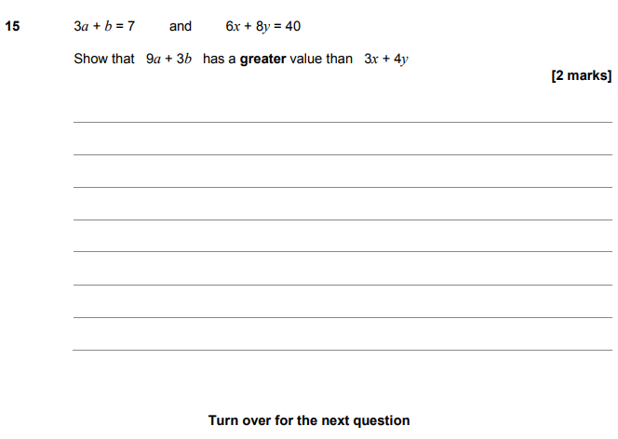

AQA Thursday 25 May 2017– Morning (Non-Calculator) Foundation Tier

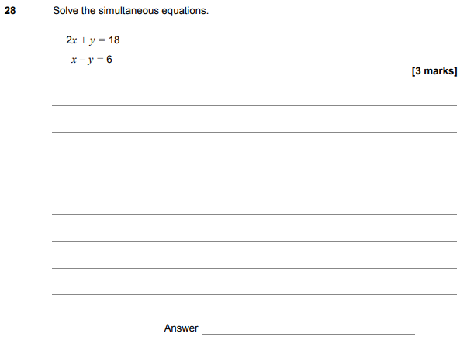

AQA Sample Paper 1– Morning (Non-Calculator) Foundation Tier

